1. **INTRODUCTION**  Consultants are people who are trained in recognizing problems and shaping solutions to those problems.

**1.1 OVERVIEW**

Bright ideas are a company specializing in offering help and support to organizations requiring assistance to deliver their development program and ambitions.

**1.2 PURPOSE**

To offer leadership on an interim or short term basis to drive delivery of your development program and goals

**2.PROBLEM DEFINITION AND DESIGN THINKING**

2.1 Empathy Map 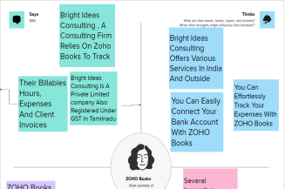

2.2 ideation and brainstorming map

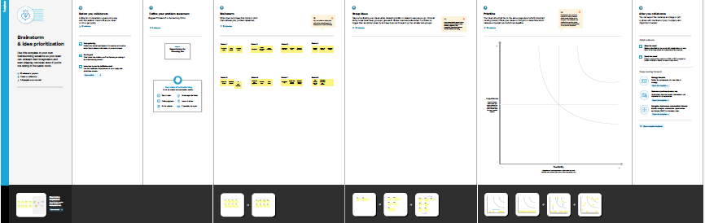

3.**RESULTS**

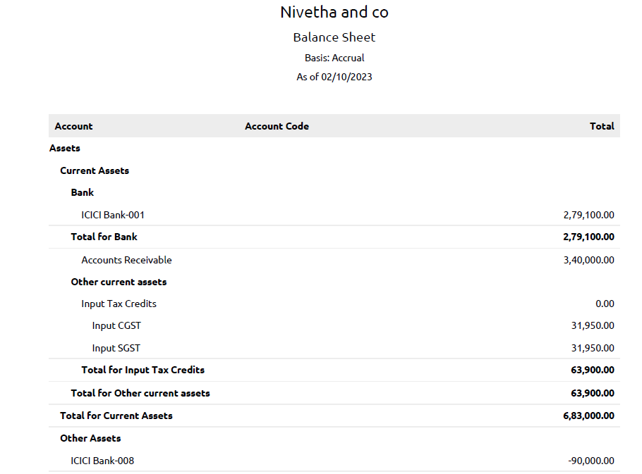

**4. ADVANTAGES AND DISADVANTAGES**

Professional and lack strong work ethics or cannot sustain long hours don’t typically succeed in consulting. If you value the 40 –hours work weeks and 8.00 to 5.00work- life balance and weekends off and holidays all the time

Consultants can provide expertise and an objective eye to help guide a business,with difference consultants specializing in various industries and areas,including strstegy and management,oprations,human resourses,finances,funding opportunities,IT,and sales and marketing

**5.APPLICATIONS**

Its has many satisfying benefits including seamless collaboration,templates, and repositories that give work and project the exposure it needs.

**6.CONCLUSION**

This program has been successfully executed

**7.FUTURE SCOPE**

Zoho development is going to focus on cloud service

**8.APPENDIX**

**A. SourseCode**